FSAD – WEEK 1 :
CREATE TABLE [STUDENT]
CREATE TABLE STUDENTS2(student_Name VARCHAR(100),vtu_no VARCHAR(100) PRIMARY KEY,Email_id VARCHAR(100),Department VARCHAR(100));
Output
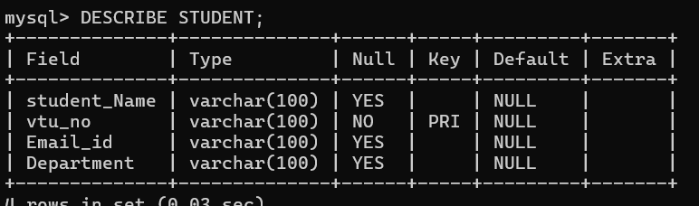

INSERT
Inserting Data into Tables
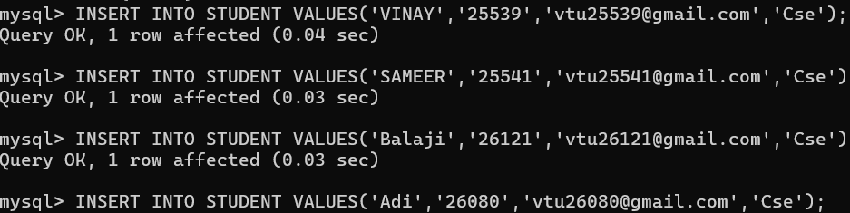

Output: 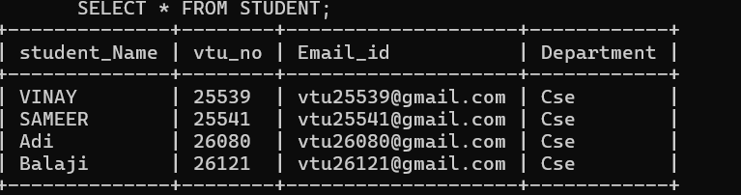

Selecting Records using different Clauses :
WHERE Clause:
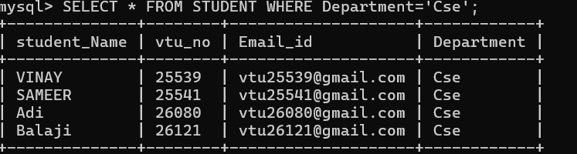

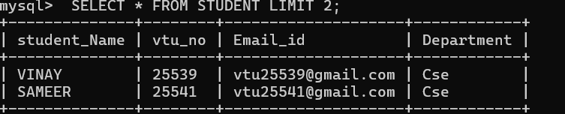
LIMIT Clause: setting limit “3”
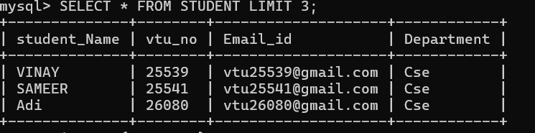
Here , Limit “1”
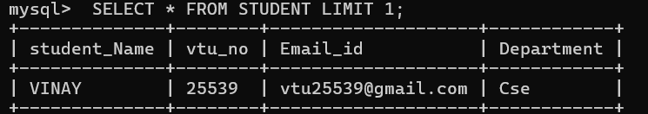

ORDER BY: It will place records in Ascending order
SELECT * FROM STUDENTS2 ORDER BY Department ASC;
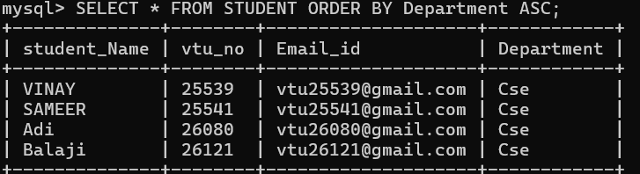
LIKE Clause:
SELECT * FROM STUDENT WHERE vtu_no LIKE '25539';
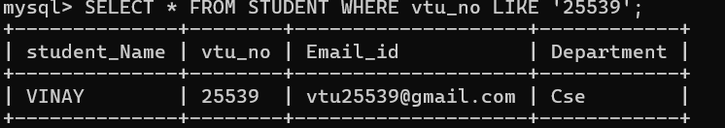
GROUP BY & HAVING:
SELECT Department,COUNT(*) AS Total_student_Names FROM STUDENT GROUP BY Department HAVING COUNT(*)>1;
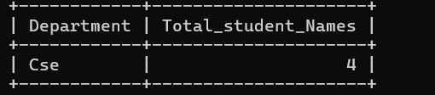
CREATE COURSE TABLE:
CREATE TABLE Course(Course_code VARCHAR(10) PRIMARY KEY , Course_name VARCHAR(50),Faculty_id INT,Faculty_Email VARCHAR(100));
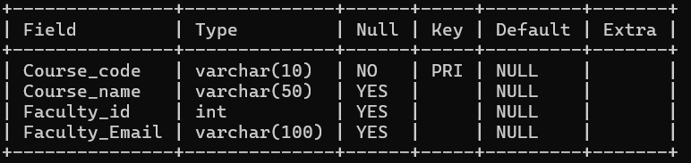
INSERT: Inserting data into table
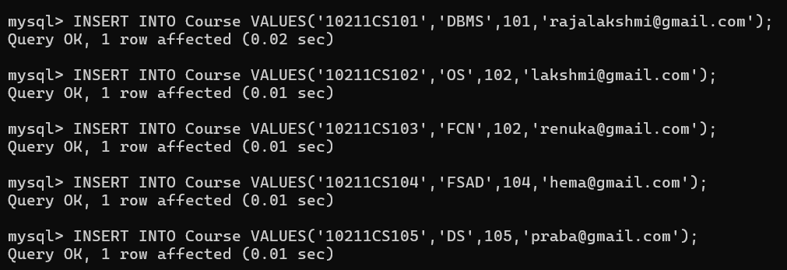
Output:
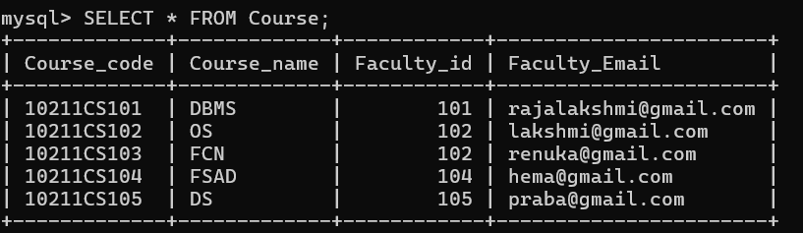
ORDER BY:
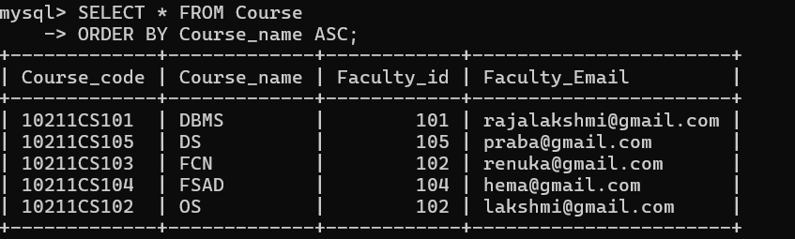
LIKE Clause:
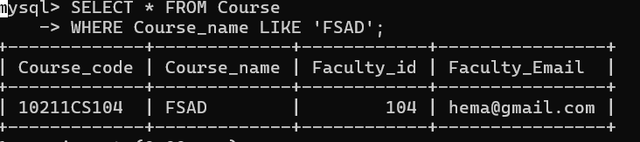
SQL JOINS
INNER JOIN:
SELECT s.student_Name, s.Department, c.Course_name
FROM STUDENT s
INNER JOIN Course c
ON s.Department = c.Course_name;
Output:
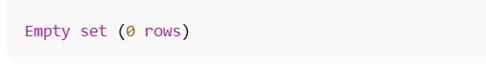
LEFT JOIN:
SELECT s.student_Name, s.Department, c.Course_code, c.Course_name
FROM STUDENT s
LEFT JOIN Course c
ON s.Department = c.Course_name;
Output:
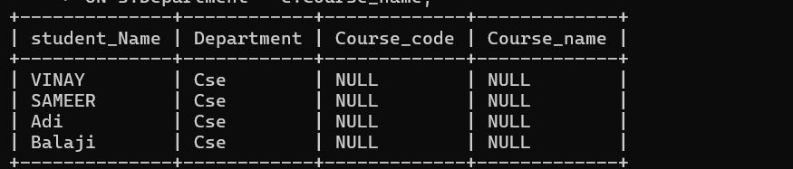
Right Join :
SELECT s.student_Name, s.Department, c.Course_code, c.Course_name
FROM STUDENT s
RIGHT JOIN Course c
ON s.Department = c.Course_name;
Output:
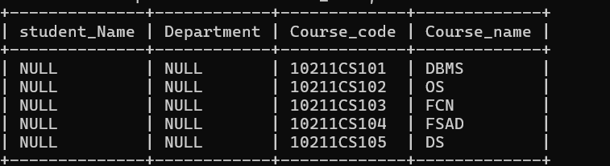
Cross Join :
SELECT s.student_Name, c.Course_name
FROM STUDENT s
CROSS JOIN Course c;
